LEDuino
Rev B
Manual
v0.5

Copyright 20120101
Introduction

The LEDuino is a Arduino with a number of additional interfaces:
- CAN – Controller Access Net is a bidirectional 2-wire bus developed and owned by Bosch, that is used in automobiles and industry.
- I2C – Inter-Integrated Circuit bus is a 2-wire bidirectional interconnect bus with collision avoidance developed and owned by Phillips, that is primarily used for shorter distances, especially for interconnecting electronic components and boards.
- Loconet – a proprietary bidirectional bus developed and owned by Digitrax, that is used as an accessory and throttel bus for model railroads.
- DCC – Digital Command Control is bus developed by Lenz and sanctioned by the National Model Railroad Association (NMRA), that is used in MRR for driving trains.
1
2
3
4
The Interfaces

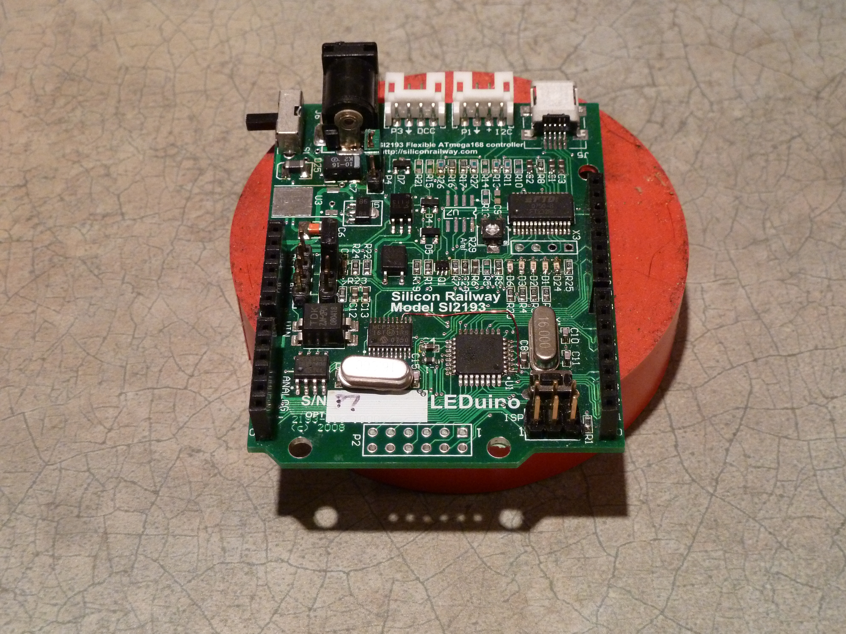
- DC Power.
a
- DCC / Loconet connector.
c
- I2C.
- USB.
- CAN
5
- Lighting connector
d
- ISP

The Headers
b
- Power switch
f
- Power (Arduino)
- ISP-select
e
- Pin 9-16 (Arduino)
- Analog pins (Arduino)
- Pins 1-8 (Arduino)
6
7

LEDuino Pin Out

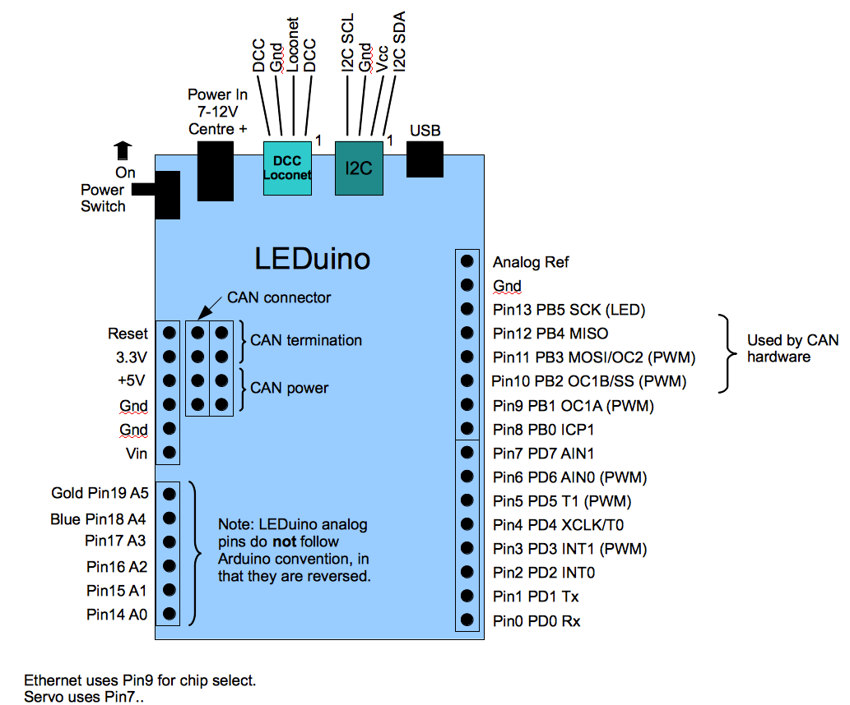
LEDuino Rev B has some Arduino incompatibilities and caviets:
- The PortA pins are reversed. This is a problem for shields that use I2C.
- Pins 10-13 are used by the onboard CAN circuitry. This may conflict with other shields, such as Ethernet shields.
- The ICSP port is in a different place. This may cause difficulties with some shields.

Leduino RevB has additional capabilities and connectors from the official Arduinos:
- CAN hardware and connector.
- DCC hardware and connector.
- Loconet-compatible hardware and connector. Strict compliance has not been established and the user should use at own risk.
- I2C hardware and connector.
- A lighting connector.

Interface Descriptions

- DC Power: input, this will accept a 2.1 mm jack, centre positive, 7-12VDC.

- DCC / Loconet connector: bidirectional, left-to-right
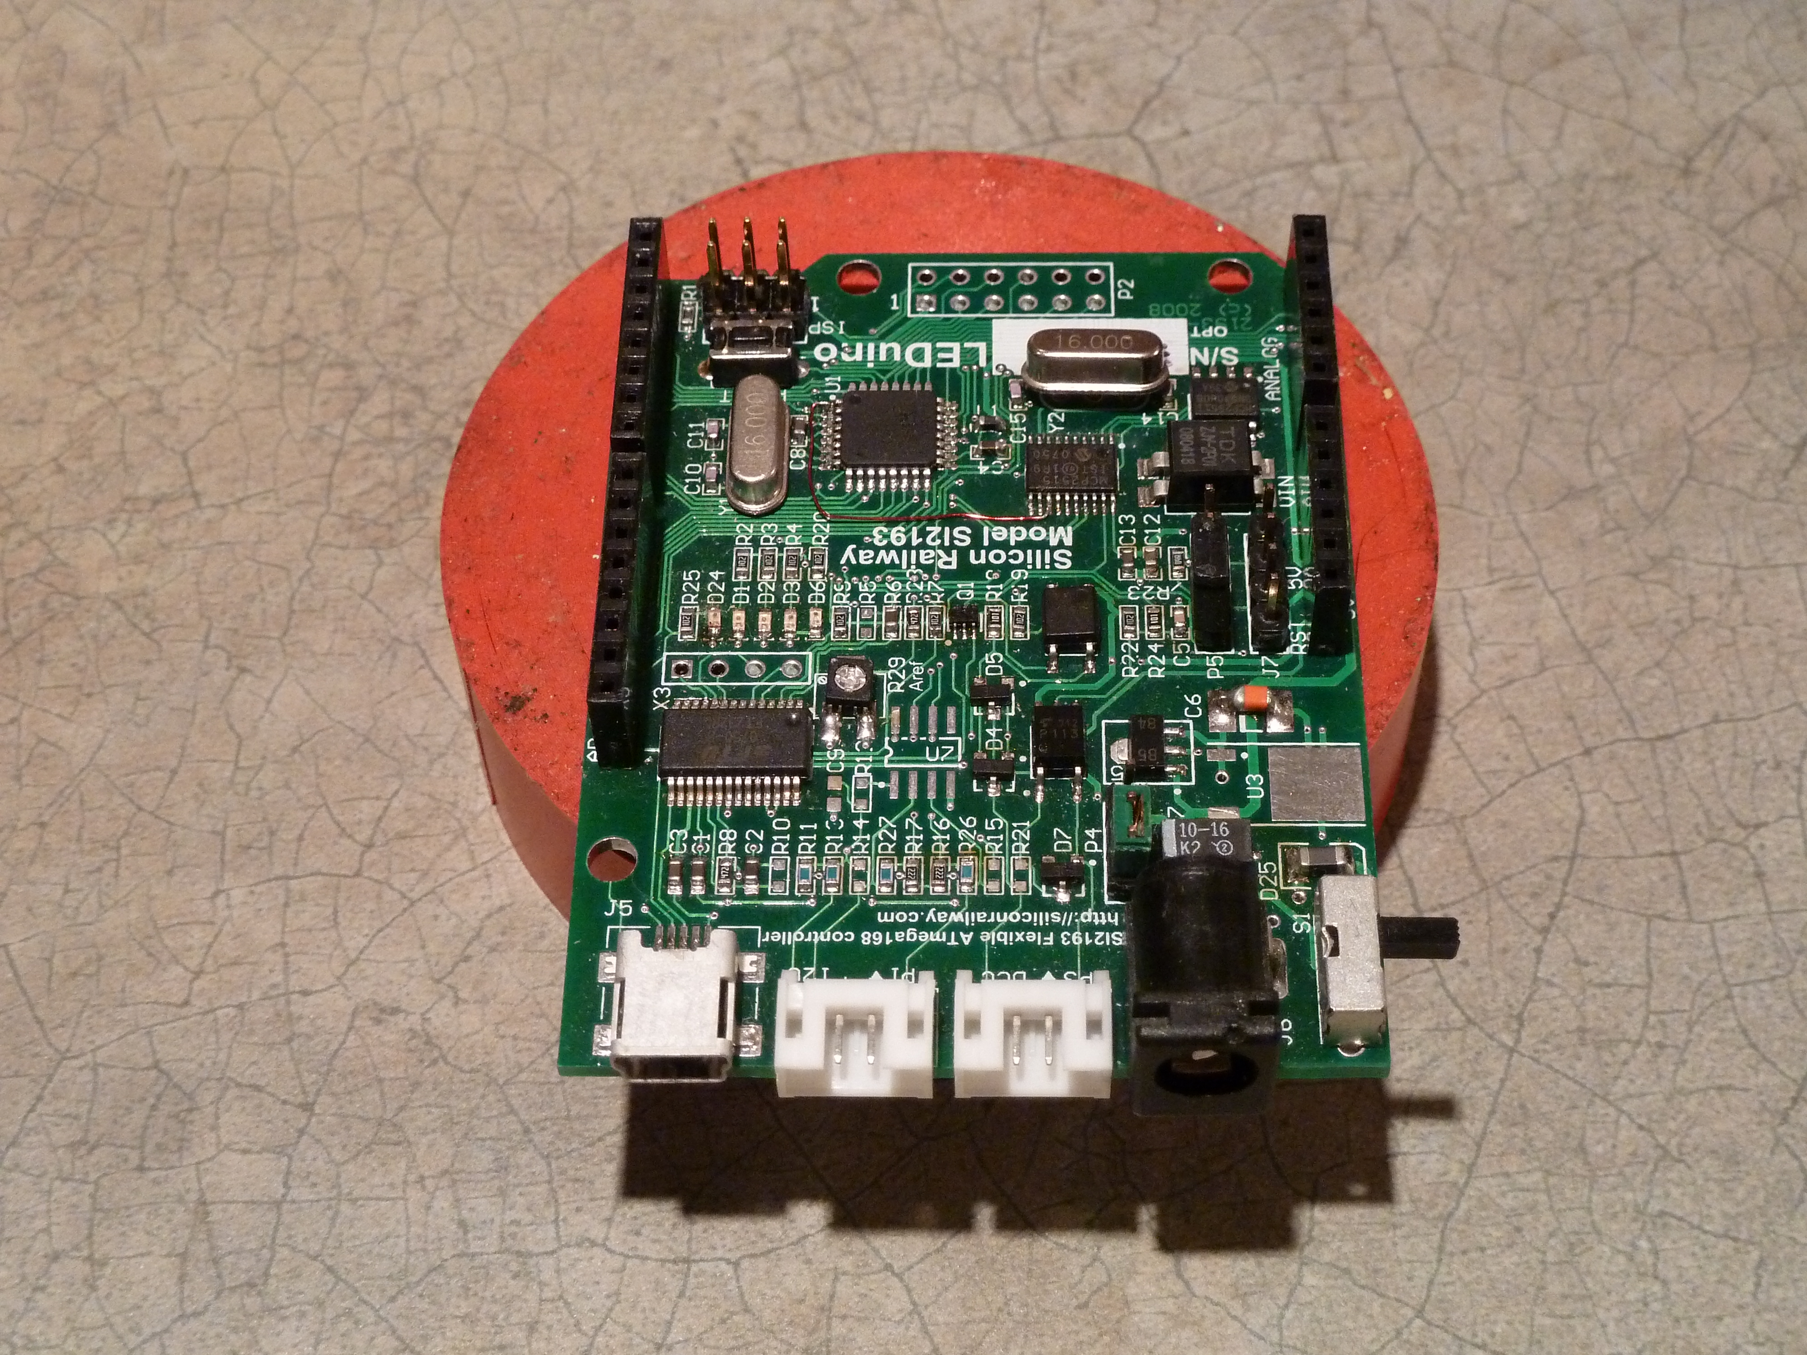
  - Pins 1 & 4 connect to the external DCC signal. These are optoisolated in both directions.
  - Pin 2: Loconet signal
  - Pin 3: Loconet ground

- I2C: bidirectional, left-to-right:
1
1
  - Pin 1: SDA
  - Pin 2: external power to the driver chip (5V)
  - Pin 3: external ground
DCC /
Loconet
USB
  - Pin 4: SCL
I2C
- USB: bidirectional

- CAN: bidirectional, left-to-right:
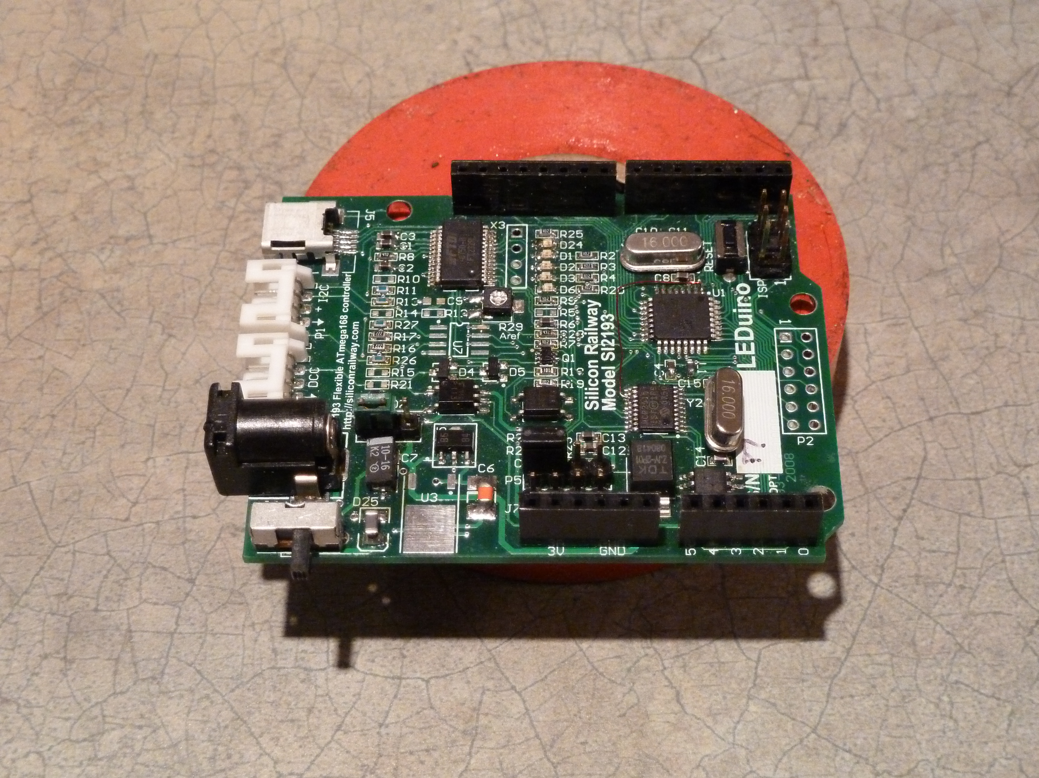
  - Pin 4: ground
CAN
Options
  - Pin 3: CAN
  - Pin 2: CAN
  - Pin 1: power (5V)
CAN

Headers:

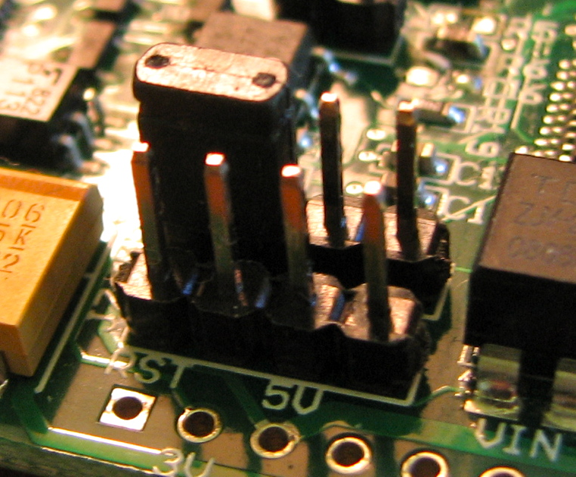
- JMP1 ISP:
Allows programming of the ATMega168 via the USB port, or via the 6-pin programming header.
  - On = ISP reset and programming activated.
  - Off = USB reset and programming
- JMP2 RST:
Allows selection of the reset signal.
  - On = allow reset from USB, this allows the Arduino IDE to rest the board, and start downloading.
  - Off = reset is from 6-pin programming header.
- JMP3 Power Source:
Determines whether the LEDuino is powered from USB or external/CAN
  - Jumper Pin 1 (closest to power socket) & 2: Power is from the external power socket or from CAN
  - Pin2&3: Power from USB
- JMP4 CAN configuration:
  - Pins 3&4:
On=CAN is terminated,
Off = CAN is not terminated
  - Pins 1&2:
Off: No power is supplied or received from the CAN connector.
On: The CAN connector is connected to the LEDuino's raw power. The power switch is active. If this LEDunio is powered via the power connector, then it will supply that to the CAN bus, if it is unpowered, then it can receive power from the CAN bus. Note, only one LEDuino should be powered at one time if using the CAN bus for power.
- X3 Header4: USB-serial (not normally fitted).
USB CTS, DSR, DCD, RI signal access. Note that some of these signals are routed through the selector chip, so that you can do programming via usb, see below.
- P7 ISP:
Serial programming connector. This is compatible with standard Atmel tools.

Using the interfaces

CAN
The LEDuino optionally has a CAN interface (Controller Access Network). CAN is a robust bus which uses a 2-wire differential pair for communication, and is used extensively in industry, for example as an internal bus in automobiles. It was developed and is owned by Bosch. It is described at: http://en.wikipedia.org/wiki/Controller_area_network. It has support for collision-avoidance, content filtering, and reliability control.
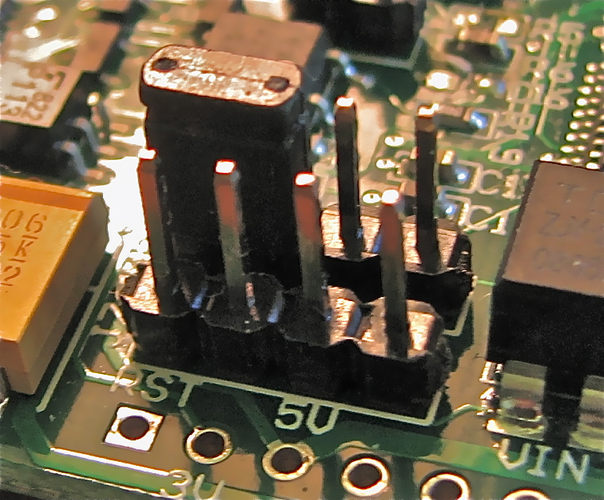

Jumper on termination select pins

Power select pins

Power CAN+ CAN- Ground

On the LEDuino, revA and revB, CAN is accessed via a 4-pin 0.1” male header. The two centre pins are the differential CAN signal, and therefore a minimal CAN connection can use these two pins alone. Provision has been made to allow proper termination of the CAN by applying a jumper to header JMP4, pins 3&4.

Power can be supply to or from the CAN connector, by using all four pins, with pins 1& 4 carrying the power. To use this option, jumper pins 1&2 of JMP4, as shown in the diagram above. Note that the power switch also needs to be turned on. Caution: there should be only one source of power to teh CAN bus.

DCC
DCC stands for “Digital Command Control” is a 2-wire system that is used to supply both power and control signals through the rails to locomotives. It is also used to control model-railroad accessories. The LEDuino (revA and B) can receive DCC as therefore act as a DCC-decoder. Officially the two wires are supposed to carry the same signal out of phase, however many DCC sources only supply the DCC signal on one wire, while the the other is ground. The LEDuino uses P3 connector to connect to DCC on pins 1&4. The signal is optoisolated, so that it can be used without fear of ground loops.

The ATMega168/328 uses PD2/INT0 (Arduino pin2) to receive DCC packets, and on RevC can Ack these via PD7 / AIN1 (Arduino pin7).

An Arduino library is available at: http://sourceforge.net/projects/opendcc/ and more information is at: http://www.opendcc.com/index_e.html.

Loconet
Loconet is a proprietary protocol developed by Digitrax. As such, SR cannot give direct support to its use. It uses two wires, and these are carried on pins 2&3 of the DCC connector, P3. The Loconet messages are received on PB0 / ICP (Arduino pin8), and the Loconet Ack is produced by PD6 (Arduino pin6). See: http://www.digitrax.com/v1/loco1hdr.htm for further details on the protocol. An Arduino library is available at: http://sourceforge.net/projects/embeddedloconet/ and an example of its use is at http://spcoast.com/wiki/index.php/Arduino_Loconet_Example1.

I2C
The LEDuino has a buffered I2C interface. This is a 2-wire bus invented and owned by Phillips (NXP) that is meant for short runs, which is described at http://en.wikipedia.org/wiki/I2C. It has hardware assisted addressing, and collision avoidance. The I2C is accessed via a 4-pin socket which carries: SDA, power, ground, and SCL. More information and Arduino libraries are available at: http://www.arduino.cc/playground/Learning/I2C.

USB
USB stands for Universal Serial Bus, and was developed to replace the need for RS232. It is fast and allows multiple serial streams through it.

The LEDuino uses a mini-usb connector and converts the USB to a single serial stream. A FTDI FT232 usb controller converts the usb signals to a serial stream which connect to the cpu's Rx and Tx pins (Pin 0 & 1). In addition, the CTS, DSR, DCD, and RI signals are brought to the X3 header.
Programming without a bootloader
The ISP-option header will allow serial programming of the microporcessor by either the ISP connector or via USB. The ISP-option jumper selects whether the ISP header or FT232 signals are connected to the to the mpu's SCK, MISO, MOSI. See: for instructions for its use see:http://www.geocities.jp/arduino_diecimila/bootloader/index_en.html.

Interface | Connector | Signals | Circuitry | CPU Pins | Arduino Pin
Power | 2.1mm barrel | 7-12VDC / Ground | Fullwave rectifier and voltage regulator | VCC / GND
DCC | Pins 1&4 on P3 | DCC+ / DCC- | Rcv: optoislated  Send: optoisolated | Rcv: PD2/INT0  Send: PD7 | Rcv: 2  Send:7
Loconet | Pins 2&3 on P3 | LN+ / Gnd | Rcv: Voltage divider  Send: Active pull-down via NPN | Rcv: PB0/ICP  Send: PD6 | Rcv: 8  Send: 6
I2C | Pins 1&4 on P1 | SDA / SCL | Buffered by I2C driver chip | SDA: PC4  SCL: PC5 | SDA: A4  SCL: A5
CAN | Pins 2&3 on J7 | CAN+ / CAN- | CAN-driver, MCP2515 CAN controller, SPI | SCK: PB5  MISO: PB4  MOSI: PB3  CS: PB2 | SCK: 13  MISO: 12  MOSI: 11  CS: 10
USB | J5 Mini-usb | Vbus / U- / U+ / Gnd | FTDI FT232 USB controller | Rcv: PD0  Send: PD1 | Rcv: 0  Send: 1
USB | J5 Mini-usb | Vbus / U- / U+ / Gnd | USB-programming | SCK: PB5  MISO: PB4  MOSI: PB3  /Reset: PC6 | SCK: 13  MISO: 12  MOSI: 11  /Reset: J4 reset

- End -

